**Tutorial – 5**

1. Find type of exception occurs in given code. Rewrite code that handle Exception using try and catch block.

public class ExceptionDemo1

{

    public static void main(String args[])

    {

        int number=50/0;

        System.out.println("number=" + number);

    }

  }

**Code:**

public class Main1 {

    public static void main(String args[]) {

        try {

            int number = 50 / 0;

            System.out.println("number=" + number);

        } catch (ArithmeticException e) {

            System.out.println("Error: " + e.getMessage());

        }

    }

}

**Output Screenshot:**

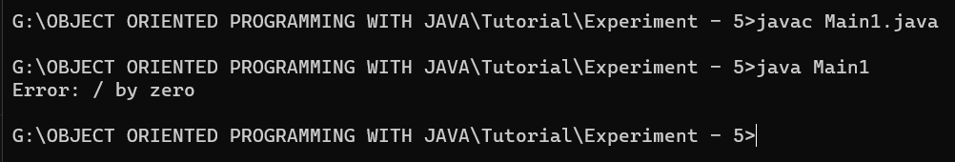

1. Create array of numbers with size= 5. try to access element of index 10 and find is there any exception occurs? Write code to handle exception.

**Code:**

public class Main2 {

    public static void main(String[] args) {

        int[] numbers = new int[5];

        try {

            numbers[10] = 100; // Trying to access an element of index 10

        } catch (ArrayIndexOutOfBoundsException e) {

            System.out.println("Error: " + e.getMessage()); // Handling the exception

        }

    }

}

**Output Screenshot:**

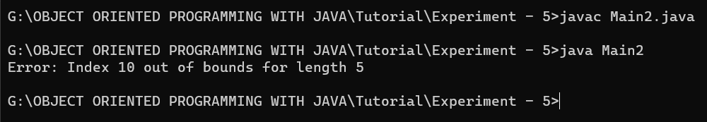

1. Find type of exception occurs in given code. Rewrite code that handle Exception using nested- try and catch block.

public class nestedtry  
{  
public static void main(String args[])  
{  
  
    int b=30/0;  
    System.out.println("going to divide by 0");  
    int a[]=new int[5];  
    a[5]=10;  
    System.out.println(a[5]);  
}  
}

**Code:**

public class Main3 {

    public static void main(String args[]) {

        try {

            int b = 30 / 0;

            System.out.println("going to divide by 0");

            try {

                int a[] = new int[5];

                a[5] = 10;

                System.out.println(a[5]);

            } catch (ArrayIndexOutOfBoundsException e) {

                System.out.println("Error: " + e.getMessage());

            }

        } catch (ArithmeticException e) {

            System.out.println("Error: " + e.getMessage());

        }

    }

}

**Output Screenshot:**

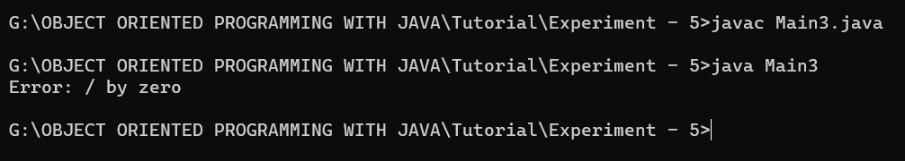

1. Demonstrate the different usage  of "final" in JAVA. give difference of all.

**Code:**

final class MyClass {

    final int MAX_VALUE = 100;

    public final void display(final int num) {

        final int value = 10;

        // value = 20;  // This will give an error as the variable is declared final

        // num = 30;    // This will give an error as the parameter is declared final

        System.out.println("MAX_VALUE: " + MAX_VALUE);

        System.out.println("num: " + num);

        System.out.println("value: " + value);

    }

}

public class Main4 {

    public static void main(String[] args) {

        MyClass obj = new MyClass();

        obj.display(50);

    }

}

**Output Screenshot:**

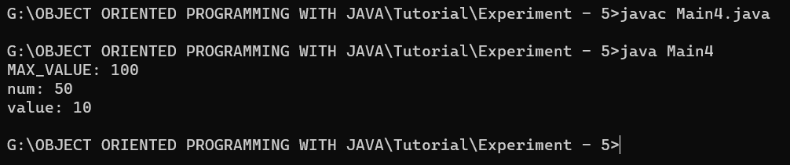

1. Demonstrate the usage of finally block.

**Code:**

import java.util.Scanner;

public class Main5 {

    public static void main(String[] args) {

        Scanner scanner = null;

        try {

            scanner = new Scanner(System.in);

            System.out.print("Enter a number: ");

            int num = scanner.nextInt();

            System.out.println("Square of " + num + " is " + (num * num));

        } catch (Exception e) {

            System.out.println("Exception caught: " + e.getMessage());

        } finally {

            if (scanner != null) {

                scanner.close();

            }

            System.out.println("Finally block executed.");

        }

    }

}

**Output Screenshot:**

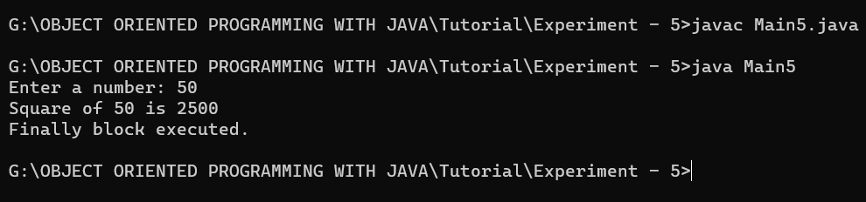

1. Create user define exception name MyException  and throw that  user define exception using constructor and toString method.

**Code:**

class MyException extends Exception {

    private String message;

    public MyException(String message) {

        this.message = message;

    }

    @Override

    public String toString() {

        return "MyException: " + message;

    }

}

public class Main6 {

    public static void main(String[] args) {

        try {

            throw new MyException("This is a custom exception message");

        } catch (MyException e) {

            System.out.println(e);

        }

    }

}

**Output Screenshot:**

